**Parte 1**

1. Donde -> significa “tiene llave en”, y entre paréntesis esta el nombre de la llave foránea

* Region -> Territories(RegionID)
* Territories -> EmployeeTerritories(TerriroryID)
* Employees -> EmployeeTerritories (EmployeeID)
* Employes -> Orders(EmployeeID)
* Shippers -> Orders(ShipVia)
* Custumers-> Orders(CustumersID)
* CustumersDemographics -> CustumerCustomerDemo(CustumerTypeID)
* CustumerCustomerDemo -> Custumers(CustumerID)
* OrderDetails -> OrdesDetails(OrderID)
* Products -> OrdesDetails(ProductID)
* Categories -> Productos(CategoryID)
* Suppliers -> Productos(SupplierID)

1. Consulta

“ select t.TerritoryID, t.TerritoryDescription, r.RegionDescription

from Territories t

inner join Region r on t.RegionID = r.RegionID;”

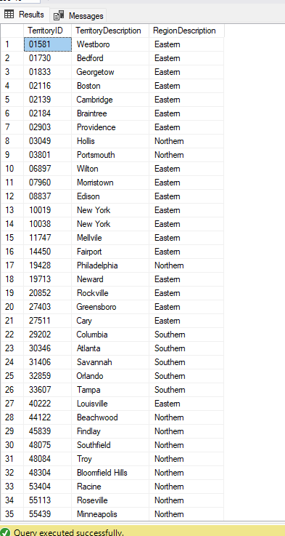

Se genera un join entre Territories y Region donde para obtener El id de la región, la descripción, RegionDescription

1. Empleado ID territorio

select * from Employees

inner join EmployeeTerritories

on Employees.EmployeeID = EmployeeTerritories.EmployeeID

1. Empleado ID territorio, y descripción territorio

select * from Employees

inner join EmployeeTerritories

on Employees.EmployeeID = EmployeeTerritories.EmployeeID

inner join Territories on EmployeeTerritories.TerritoryID = Territories.TerritoryID

**Segunda parte**

